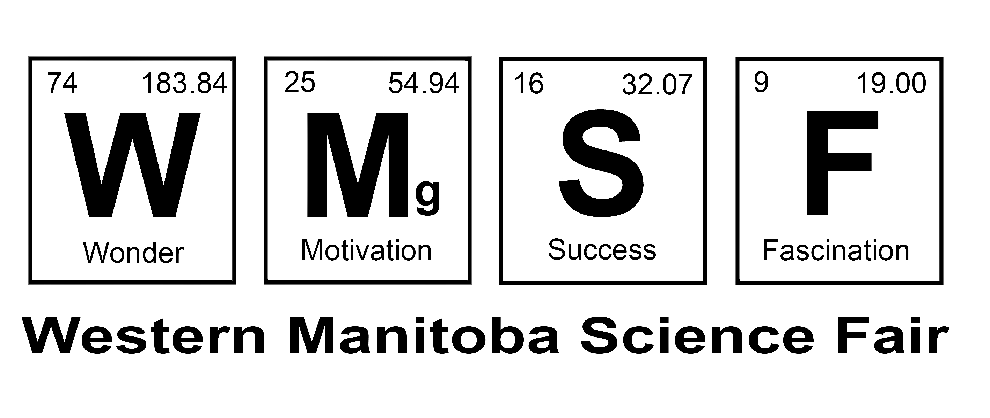
Form PHLR: Participation of Humans
Low Risk – Certification of Compliance

This form certifies that a low risk project involving the participation of humans is in full compliance with WMSF Policy Participation of Humans in Research – Low Risk. www.wmsf.com/humanparticipation

Project Title
 | First Name | Last Name | Email | Phone
Student 1
Student 2
Adult Supervisor
Chairperson, WMSF
Judging Chair, WMSF

Acknowledgement by Students:

I have read and understand WMSF Policy Participation of Humans in Research – Low Risk
www.wmsf.com/humanparticipation.

Signed - Student 1 Date Signed - Student 2 Date

Certification by Adult Supervisor:

I have read and understand WMSF Policy Participation of Humans in Research – Low Risk, and I certify that this Low Risk Project involving Human Participation is in full compliance with said Policy and that it is eligible for the Western Manitoba Science Fair.

Signed – Adult Supervisor Date

Instructions

- Documents

The following project documents must be available to the Adult Supervisor, prior to them signing this form:

  - The Survey – if your project involves a survey
  - Your Informed Consent Letter of Information that will be given to every participant in your survey
  - A blank sample of the Informed Consent Permission Form that each participant will sign

- Instructions for Students entering in the Western Manitoba Science Fair

  - Print and fill in Form PHLR – must be completely legible.
  - Obtain the required signatures.
  - Make a paper copy of the completed and signed form.
  - Store the original signed copy in a safe place.
  - Submit a copy of the signed Form PHLR with your entry form
  - Take the copy of the signed Form PHLR to the Western Manitoba Science Fair.
  - Take these three forms to the Western Manitoba Science Fair as well:
    - The Survey – if your project involves a survey
    - The Informed Consent Letter of Information that you gave to each participant in your project.
    - A blank sample of the Informed Consent Permission Form each participant signed before they did your experiment.

