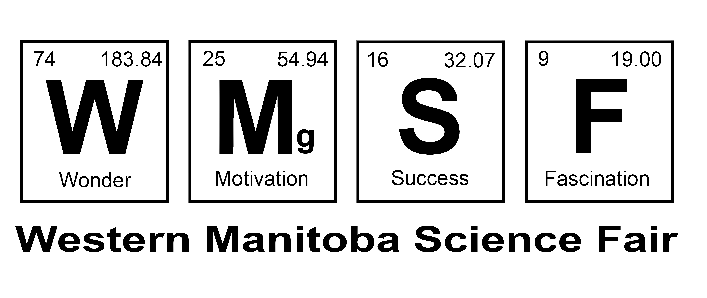

Informed Consent

Letter of Information - SAMPLE

Project Title: A Study of the On-Line Video Game Community

I am a student in Parkwood Elementary School who is preparing to enter the Parkwood Science Fair, and the information I collect will be used for this project. This letter provides the information required for you to make an informed decision about whether to participate.

Researcher and Advisors

Student Researcher Jane Smith jsmith@zzz.ca

Adult Supervisor Kate Smith ksmith@zzz.ca 204-123-4567

School: Parkwood School

Purpose of the Research

This research project will investigate the on-line gaming community to see if extensive time spent on the game affects other aspects of their lives.

What You Will Be Asked to Do in the Research
If you choose to take part in this study, I would like to interview you at a public location of your choice to discuss your experiences in gaming. In particular, I am interested in asking questions about your on-line character, server choice, your playing style, your values, perceptions and experiences in and of World of Warcraft, as well as your own opinions on how the real world is brought into World of Warcraft. I would like to record the interview in order to ensure the clarity of my hand-written notes. You may ask that the recorder be stopped at any time.

Benefits from Participating
You will learn a little about Video Games and the on-line gaming community.

Risks from Participating
There are no risks associated with this project.

Time Commitment Required
The estimate of the time commitment required is from 30 minutes to 3 hours. The interviews will take as much or as little time as you are comfortable with.

Remuneration
There is no remuneration for participating in this project.

Confidentiality of Data
All the information will be stored on the computer of the researcher, and will be password protected. No information that will identify you personally will be kept. All paper records will be shredded, and all electronic raw data files will be deleted at the end of the project using deletion software, so that the data cannot be recovered. At the Science Fair, all information will be presented anonymously. None of the participants will be identified.

Withdrawing from the project
You have the right to withdraw from the project at any time and for any reason. Contact the Adult Supervisor by telephone or email if you would like to do this.

Results
A summary of the results of this research will be sent to you by email after the Science Fair is over.

