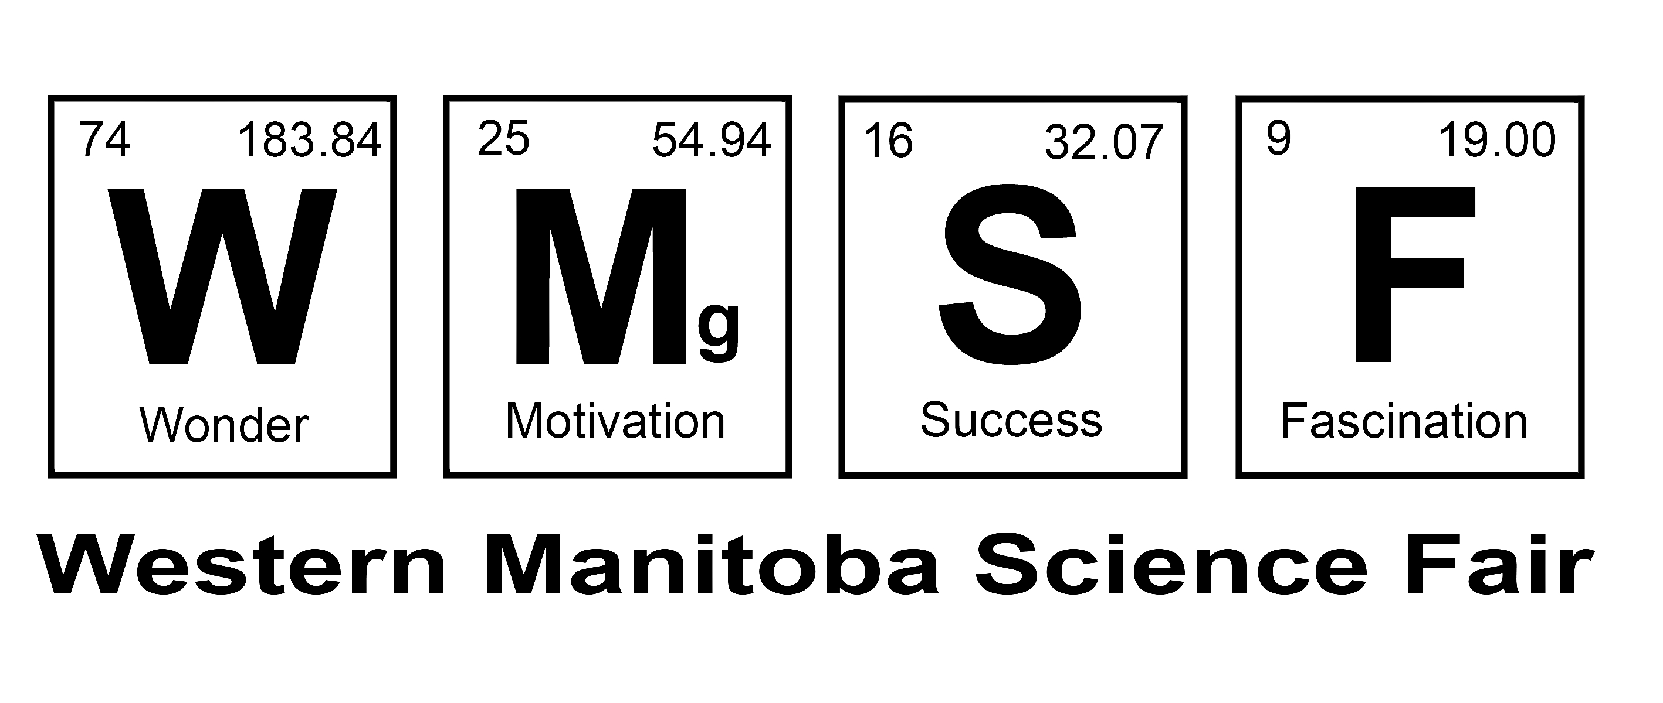

IMPLIED CONSENT - Letter of Information

Name of School
Name of Teacher
Dear Parents,
Each year the students at our school work on creating and testing a science fair topic of their choice. Often the chosen topics require the testing of other students. Anyone who participates in a science fair project must agree to do so beforehand. Typical projects involve such activities as memorizing numbers, giving an opinion about a situation or playing a game on a computer. Your child gives permission by the simple act of participating. This is called Implied Consent. Please note that all children in the class have been informed that they do not have to participate, and can opt out at any time.
- Experiments your child's class will be taking part in include:

- Purpose of the Project
This project will give the students the opportunity to explore how science is done, and to practice these skills, which will be of significant value later in their careers.
- Ask a question;
- Design an experiment or study;
- Collect some data;
- Display it in a table or chart;
- Present it to others.

- Benefits from Participating
They are helping each other with their projects.
- Risks from Participating
None
- Time Commitment Required
Typically this is 10 – 30 minutes
- Remuneration
There is no gift or remuneration given for participating.
- Confidentiality of Data
The data presented will not identify the individuals who participate. Gender and age may be published. All data will be deleted from the computer, and any paper copies shredded after the science fair.
- Withdrawing from the project
Your child is free to withdraw from the project at any time and for any reason whatsoever. Just let the teacher know, or just say “No, I prefer not to participate”.
- Results
Feedback of results will be given to any interested participants after the results have been published at the School Fair.

