Participation of Humans in Research
Low Risk Project

If your project involves collecting data from humans and is considered Low Risk, it must comply with WMSF Policy Participation of Humans in Research – Low Risk. The risk of harm to participants must not be greater or more likely than in everyday life.

Before you begin working on your project:

- Your project must have an Adult Supervisor who must complete and sign Form PHLR - Certificate of Compliance
- Participants (or their parents/guardians if they are under 18) must be provided with a Letter of Information before they participate
- Participants must sign a Permission Form before they participate

You must create the Letter of Information and Permission Form for your project. This booklet contains templates that you can use to create these documents. It also includes instructions and a sample Letter of Information.

Table of Contents

Page 1 Form PHLR – Certification of Compliance
Page 2 Letter of Information template
Page 3 Instructions for completing Letter of Information
Page 4 Sample Letter of Information
Page 5 Sample Letter of Information (cont.)
Page 6 Permission Form template

If you are entering the Western Manitoba Science Fair, please attach the following to your entry form so the judges can review them:
- A copy of the signed Form PHLR
- A copy of your Letter of Information
- A blank copy of your Permission Form
  - Do NOT submit the signed permission forms that you collect from your participants to WMSF. Keep those in a safe place until the science fair is over and you think you no longer need them. If you move on to the Canada Wide Science Fair you would keep them until after that fair. You are keeping these signed permission forms as proof that you informed your participants about the details of your project and that they agreed to participate.
- If you gave your Participants a survey as a part of your project, attached a blank copy of your survey questions.

Tip: It is a good idea to have the above documents available for judges at your school fair as well. They might not be familiar with WMSF rules or Policy, but they will be impressed at your thoroughness!

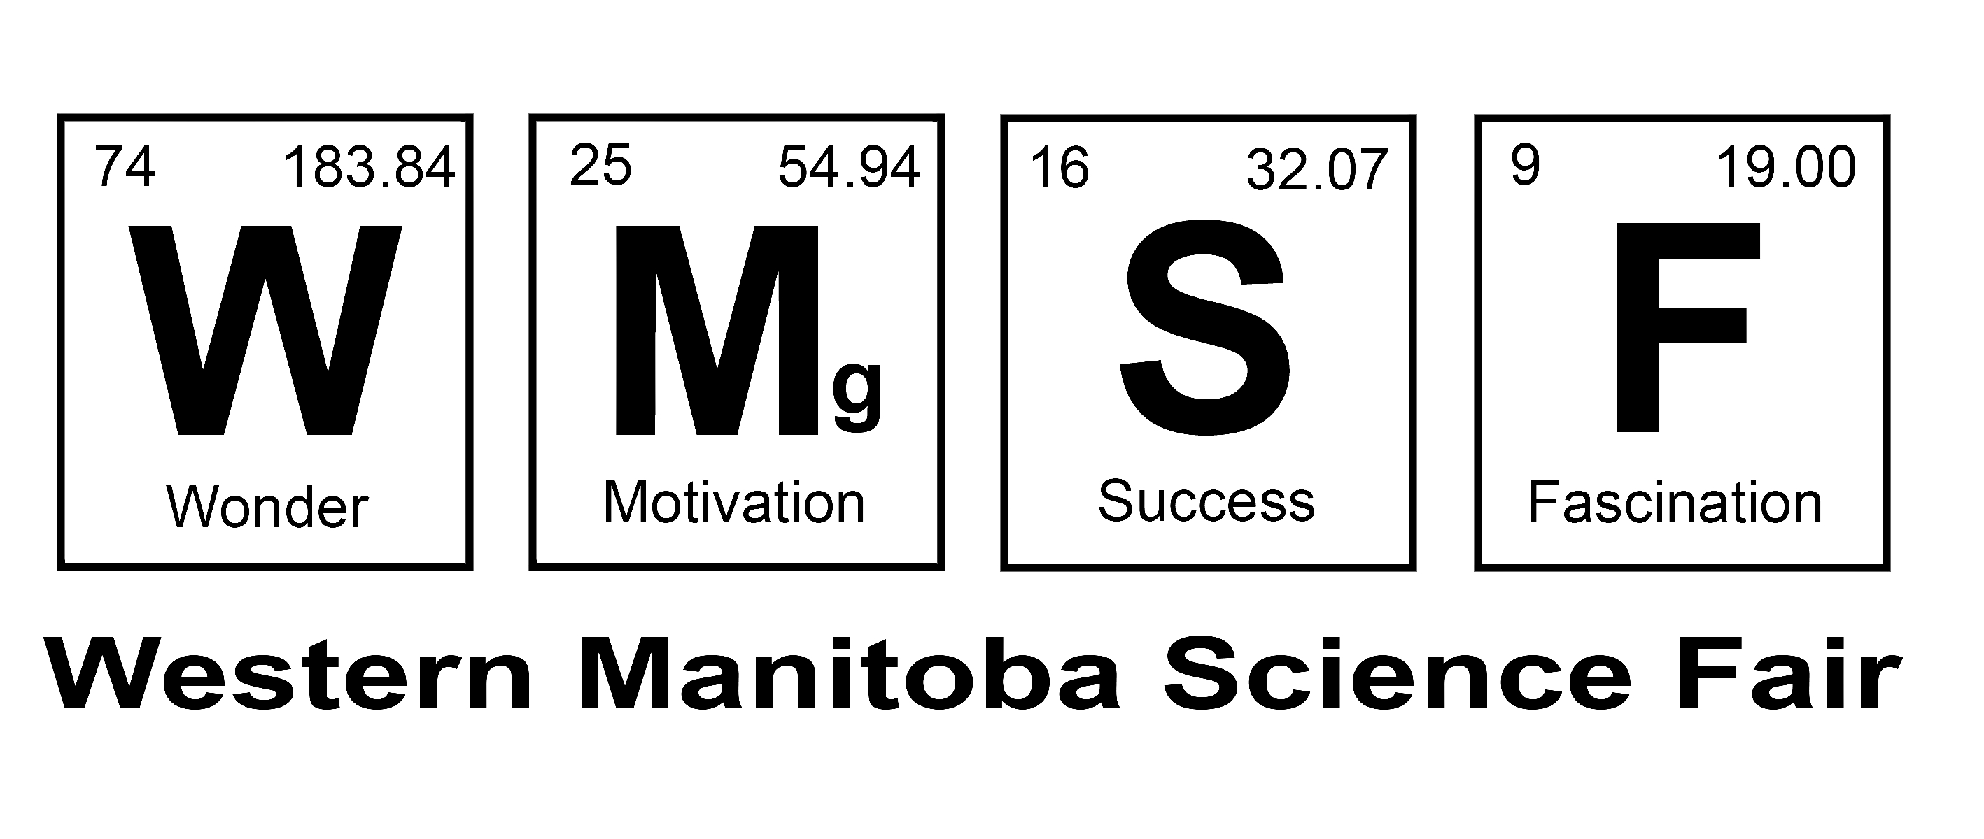
Form PHLR: Participation of Humans
Low Risk – Certification of Compliance

This form certifies that a low risk project involving the participation of humans is in full compliance with WMSF Policy Participation of Humans in Research – Low Risk. https://www.wmsf.com/ethics/hplowriskpolicy

Project Title
 | First Name | Last Name | Email | Phone
Student 1
Student 2
Adult Supervisor
Chairperson, WMSF | Trevor | Maguire | info@wmsf.com | 204-761-0400
Judging Chair, WMSF | Robyn | Forsman | judging@wmsf.com | 204-570-0271

The following project documents must be available to the Adult Supervisor, prior to them signing this form:

  - The Survey – if your project involves a survey
  - Your Letter of Information that will be given to every participant in your survey
  - A blank sample of the Permission Form that each participant will sign

Acknowledgement by Student Researcher(s):

I have read and understand WMSF Policy Participation of Humans in Research – Low Risk
https://www.wmsf.com/ethics/hplowriskpolicy.

Signed - Student 1 Date Signed - Student 2 Date

Certification by Adult Supervisor:

I have read and understand WMSF Policy Participation of Humans in Research – Low Risk, and I certify that this Low Risk Project involving Human Participation is in full compliance with said Policy and that it is eligible for the Western Manitoba Science Fair.

Signed – Adult Supervisor Date

Letter of Information

Insert Project Title Here

- Researcher and Advisors

 | First Name | Last Name | Phone | Email
Student 1
Student 2
Adult Supervisor
School

- Purpose of the Research

- Benefits from Participating

- Risks from Participating

- Time Commitment Required

- Remuneration

- Confidentiality of Data

- Withdrawing from the project

- Results

Instructions for completing Letter of Information

- Researcher and Advisors
Give the name(s) of the researcher(s); school; project title; the Adult Supervisor’s name, email address and telephone number.

- Purpose of the Research
Describe the purpose of this research.

- Benefits from Participating
Define the benefits to the participant from participating.

- Risks from Participating
Discuss the risks to the participant from participating.

- Time Commitment Required
Give the time each participant will contribute to the project.

- Remuneration
Must state that there will be no remuneration paid for participation in this project.

- Confidentiality of Data

How will the confidentiality of the data be guaranteed?

- Withdrawing from the Project
Explain that each participant has the right to withdraw from the project at any time, and for any reason.

- Results
Explain how the results of the research will be communicated to the participant

- Other info
Include any other relevant info that you feel the participants should have.

Distribution

Give a copy of your Letter of Information to each of the participants in your study before they participate.

Western Manitoba Science Fair: Submit a copy of this letter with your entry form, and have a copy of this letter at your project.

Letter of Information

This is a SAMPLE Letter of Information. Feel free to use some or all of the wording in this example to complete your Letter of Information.

Project Title: A Study of the On-Line Video Game Community

I am a student in Parkwood Elementary School who is preparing to enter the Parkwood Science Fair, and the information I collect will be used for this project. This letter provides the information required for you to make an informed decision about whether to participate.

Researcher and Advisors

Student Researcher Jane Smith jsmith@zzz.ca

Adult Supervisor Kate Smith ksmith@zzz.ca 204-123-4567

School: Parkwood School

Purpose of the Research

This research project will investigate the on-line gaming community to see if extensive time spent on the game affects other aspects of their lives.

What You Will Be Asked to Do in the Research
If you choose to take part in this study, I would like to interview you at a public location of your choice to discuss your experiences in gaming. In particular, I am interested in asking questions about your on-line character, server choice, your playing style, your values, perceptions and experiences in and of World of Warcraft, as well as your own opinions on how the real world is brought into World of Warcraft. I would like to record the interview in order to ensure the clarity of my hand-written notes. You may ask that the recorder be stopped at any time.

Benefits from Participating
You will learn a little about Video Games and the on-line gaming community.

Risks from Participating
There are no risks associated with this project.

Time Commitment Required
The estimate of the time commitment required is from 30 minutes to 3 hours. The interviews will take as much or as little time as you are comfortable with.

Remuneration
There is no remuneration for participating in this project.

Confidentiality of Data
All the information will be stored on the computer of the researcher, and will be password protected. No information that will identify you personally will be kept. All paper records will be shredded, and all electronic raw data files will be deleted at the end of the project using deletion software, so that the data cannot be recovered. At the Science Fair, all information will be presented anonymously. None of the participants will be identified.

Withdrawing from the project
You have the right to withdraw from the project at any time and for any reason. Contact the Adult Supervisor by telephone or email if you would like to do this.

Results
A summary of the results of this research will be sent to you by email after the Science Fair is over.

Permission Form

Project Title:

I have received the Letter of Information for this Science Fair Project, which is mine to keep. All my questions have been answered to my satisfaction, and I agree to participate in this research.

Name of Participant (print):

Signature of Participant: _________________________________

Date:

Name of Parent of Guardian¹:

Signature of Parent of Guardian: _____________________________

Date:

Name of person obtaining consent (Student Researcher):

Signature of person obtaining consent: ___________________________

Date:

¹ If the participant is under the age of 18, then a parent or guardian must also give permission by signing this form.
This completed form contains personal information and must be stored securely. All Informed Consent Permission Forms must be shredded after the project is no longer needed for Science Fairs.

