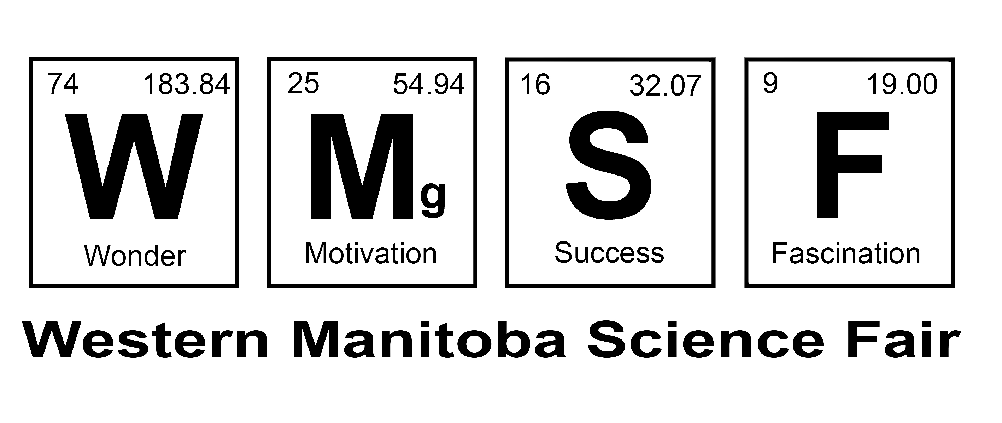

Informed Consent Permission Form
Project Title:
Date:

I have received the Letter of Information for Informed Consent for this Science Fair Project, which is mine to keep. All my questions have been answered to my satisfaction, and I agree to participate in this research.

Name of Participant (print):

Signature of Participant: _________________________________

Name of Parent of Guardian¹:

Signature of Parent of Guardian: _____________________________

Name of person obtaining consent:

Signature of person obtaining consent: ________________________

¹ If the participant is under the age of 18, then a parent or guardian must also give permission by signing this form.
This completed form contains personal information and must be stored securely. All Informed Consent Permission Forms must be shredded after the project is no longer needed for Science Fairs.

Western Manitoba Science Fair: Submit a blank copy of this letter with your entry form and have a blank copy of this letter at your project.

